**TABLE OF CONTENT**

1. Introduction

1.1 About the System

1.2 Scope

1.3 Technology Used

1. System Requirement Study

2.1 Requirement Gathering

3. System Analysis

3.1 Feasibility Study

4. Project Management

4.1 Risk Management

5. System Diagrams

5.1 Use Case Diagram

5.2 Data Flow Diagram

5.3 ER Diagram

6. Implementation Plan

6.1 Use Case Module

7. Screen Shots

8. Testing

9. Conclusion

1. Introduction

**1.1 About the system**

TestRight is a system for conducting all kind of exams and assessments online with security measures to prevent cheating and other exam related illegal activities. TestRight will eliminate the need of traditional pen-paper exams and requirement of creation of separate portals for different exams.

**1.2 Scope**

Although, there are many applications in the market that allow people to make personalized test, we still stand out with our application as we have unique feature.

**1.3 Technology Used**

We have used the following technologies:

* MongoDB
* NodeJS
* ExpressJS
* HTML 5
* CSS 3

2. System Requirement Study

**2.1 Requirement Gathering**

a. Examiner and student can login to have access to the system.

b. Examiner and the student can view the results.

c. Examiner can create test.

d. Examiner can add or edit a question.

e. Student can register for a test.

3. System Analysis

**3.1 Feasibility Study**

**Operational Feasibility**

• There is an ever-growing need of portals for examination and assessment by various organizations on different levels. TestRight provides a centralized system to make conducting examinations and assessments easier and eco-friendly.

• TestRight will benefit not only the academic sector but it will also help commercial and industrial sectors by making conducting recruitment drive easier and accessible. TestRight exams and assessment will be accessible to anyone with a computer and a stable internet connection. It will give ability to not only take your exam from any test center but also from comfort of home.

• TestRight will help examiners conduct exams smoothly without worry of any illegal activities. Examiners can create a question bank and the TestRight algorithm will automatically create unique question sets for test-takers.

• TestRight will allow scalability; the exams/assessments will be available to the audience selected by the examiners. It can be used for small institutions as well as for conducting nation-wide examinations.

**Economic Feasibility**

• This system will require servers to deploy. For prototyping and testing purposes dummy hosting and free servers can be used. Once the project scales, it must be transferred to a paid server and cloud service such as AWS.

• Hardware costs will be minimal to none as everything will be stored in cloud and remote servers. There is no plan to have a local server.

• Team will utilize freely available resources such as GitHub for version controlling and Slack for collaboration, connection and project management.

**Technical Feasibility**

• Technologies to be used are widely accepted by community and documented in abundance. Technologies such as NodeJS, MongoDB are constantly evolving with new and powerful features.

• Team members are experienced in web application development and mobile development. This will make working for TestRight system relatively easier.

4. Project Management

**4.1 Requirement Gathering**

Risk 1:User Resistance to adapt our system.

Risk 2:Issues in mutual agreement/understanding between team members

Risk 3:Not able to implement some of the functionalities due to lack of time.

Risk 4:Change in the policies of dependent tools or services (such as AWS).

Risk 5:Unavailability of team members due to unforeseeable and/or unavoidable circumstances.

Risk 6:Undefined problems encountered at the server side.

Risk 7:Undefined problems encountered at the runtime (on-going test) at client side.

Risk 8:Risk of obsoletion of the technologies our test tool uses.

Risk 9:Not able to deliver well tested product due to lack of time.

Risk 10:Issues encountered while submission or updation of test, which may lead to legal consequences.

Risk 11:User Experience problems encountered in different browsers and devices.

Risk 12:Uncertainty in addition of new modules after deployment.

Risk 13:Unable to maintain the system due to large number of out-house modules.

Risk 14:Not able to save the test in the database (Proctor side).

5. System Designs

**5.1 Use Case Diagram**

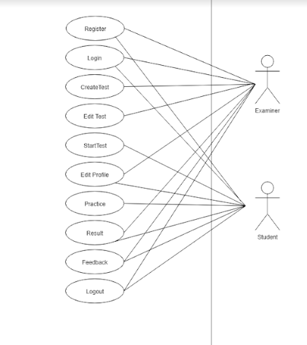

**5.2 Data Flow Diagram**

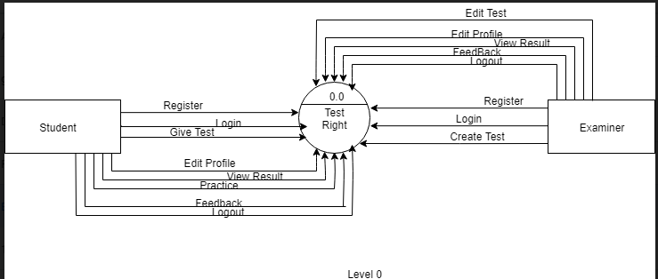

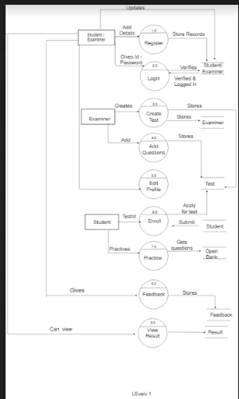

**5.3 ER Diagram**

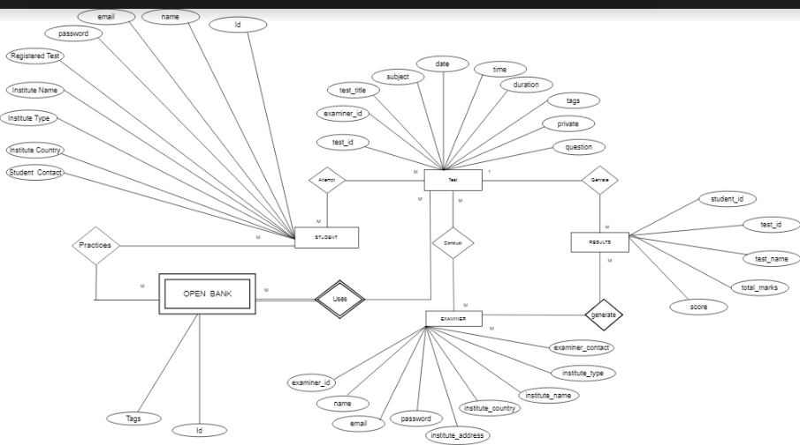

6. Implementation Plan

**6.1 Use Case Module**

|  |  |
| --- | --- |
| **Module** | **Description** |
| Student | The student is a entity which can perform activities like register, login, start test, edit profile, practice, see results and logout. |
| Examiner | The Examiner entity can perform activities like register, login, create test, edit test, edit profile, result, feedback, logout. |

7. Screen Shots

Home Page

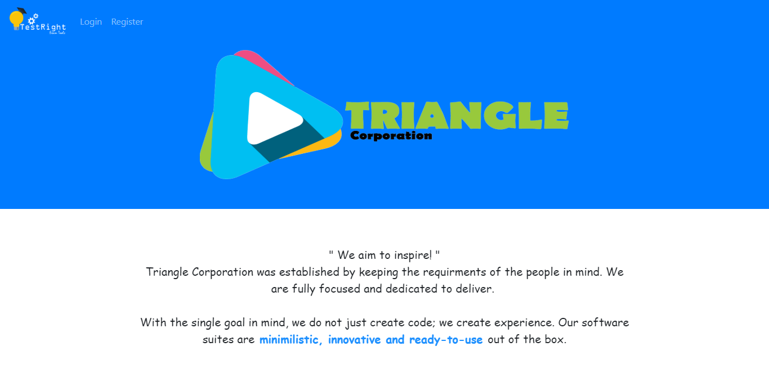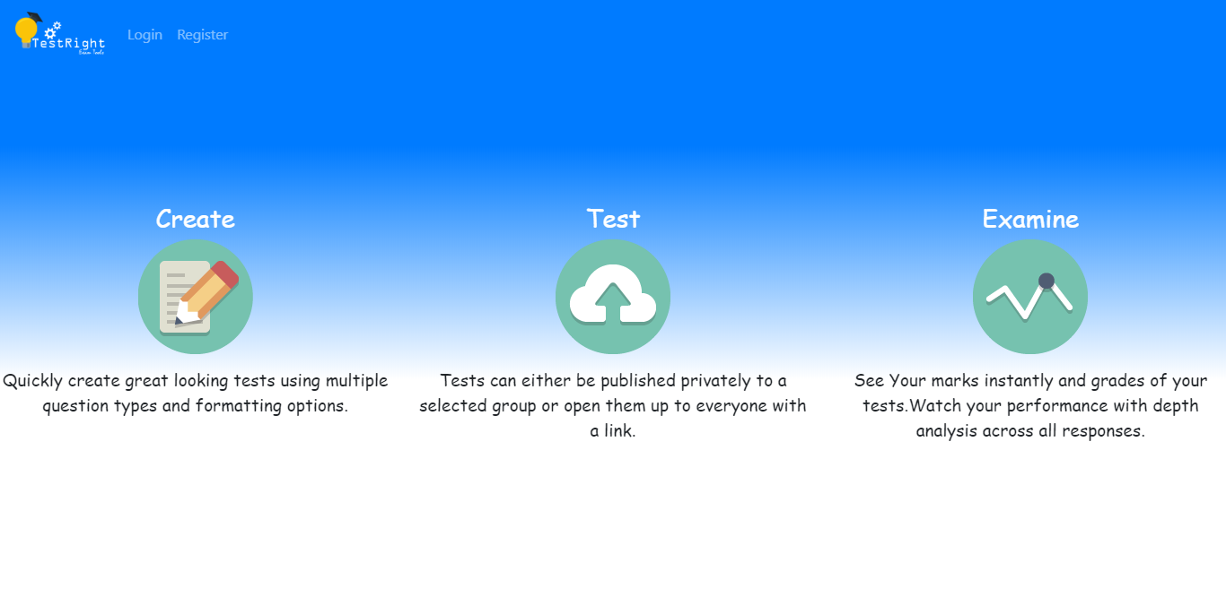

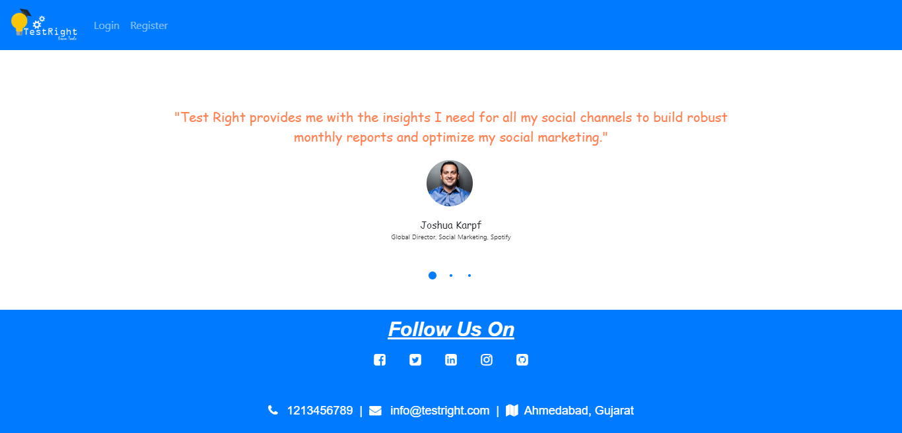

Registration

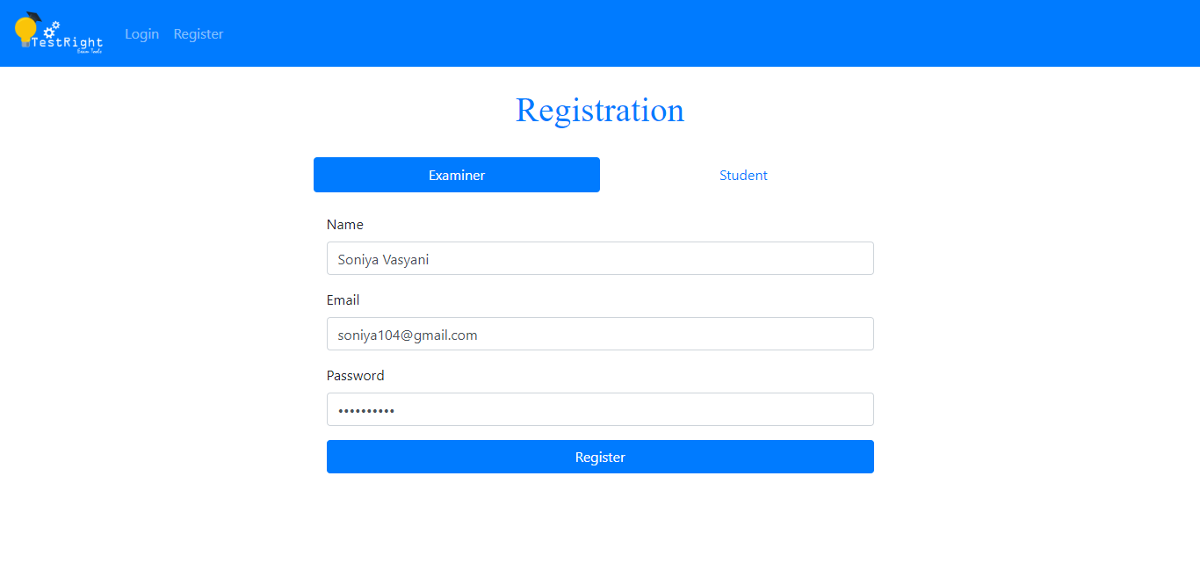

Login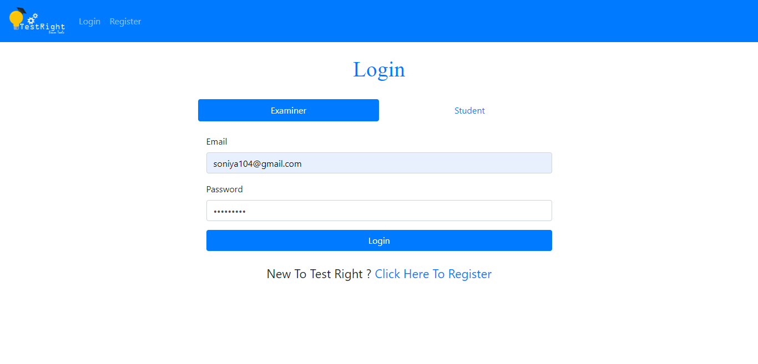

Dashboard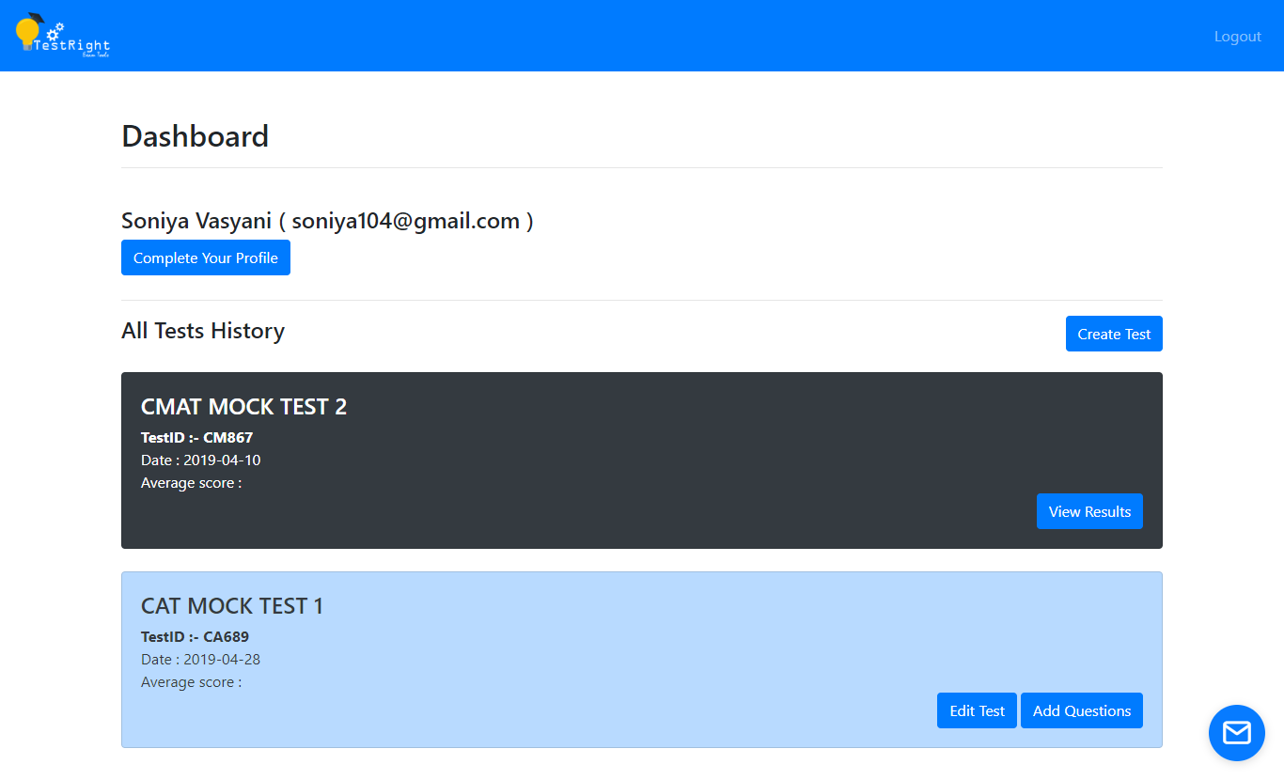

Starting a Test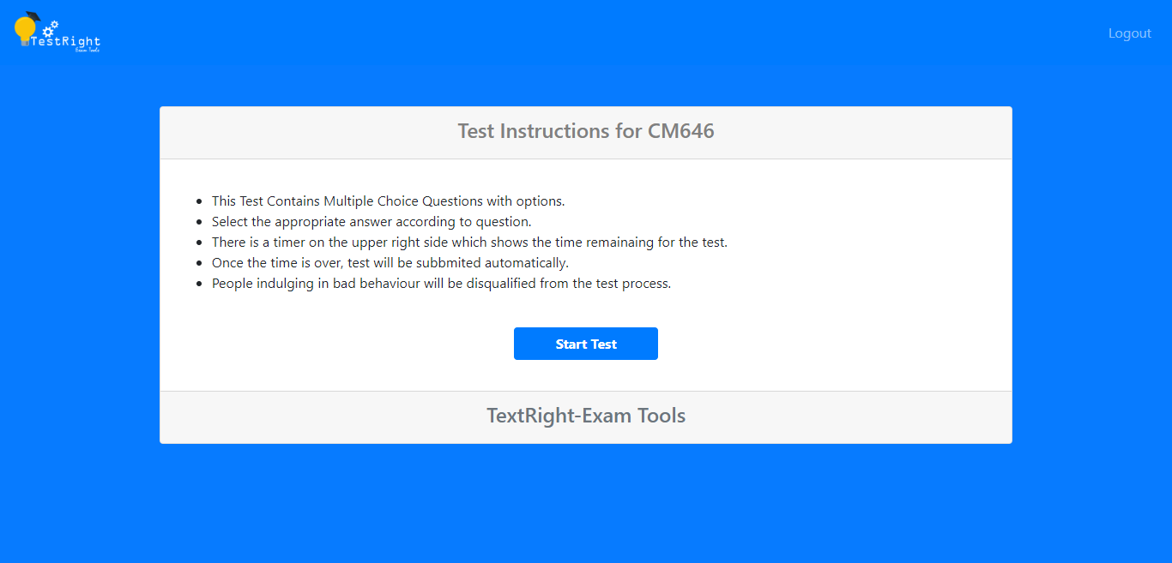

Giving the test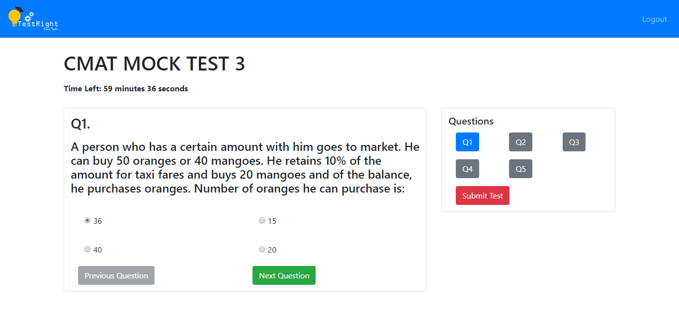

Edit Profile

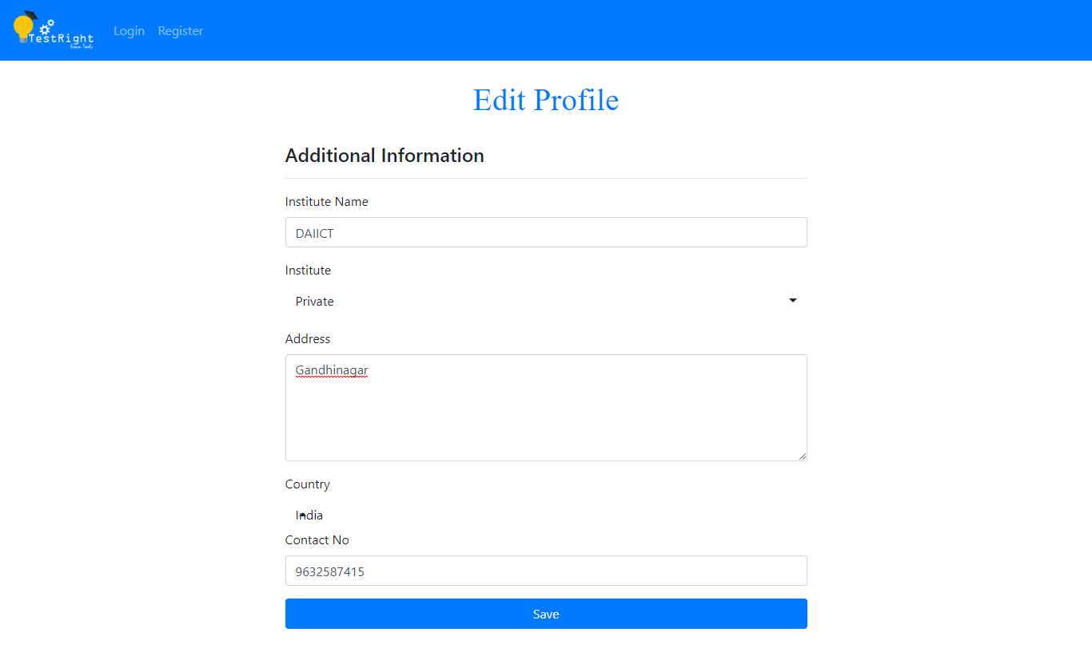Create Test

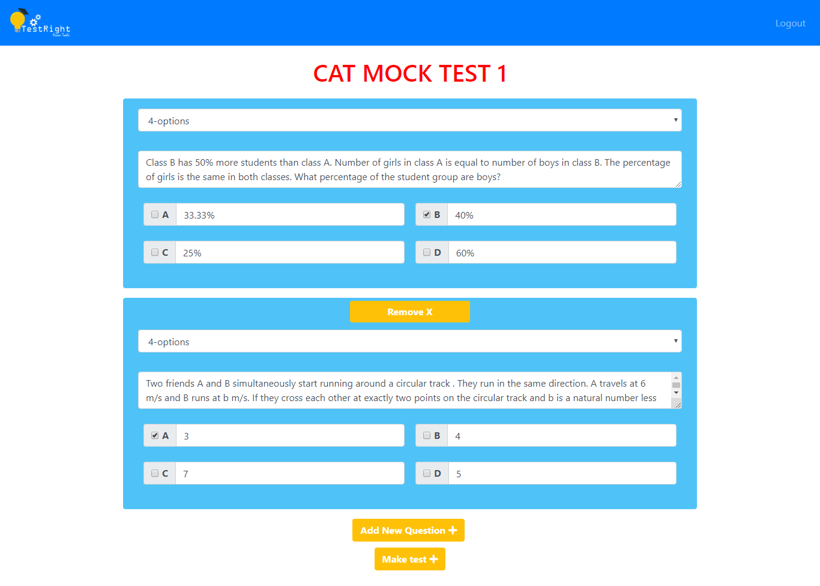

Edit Test

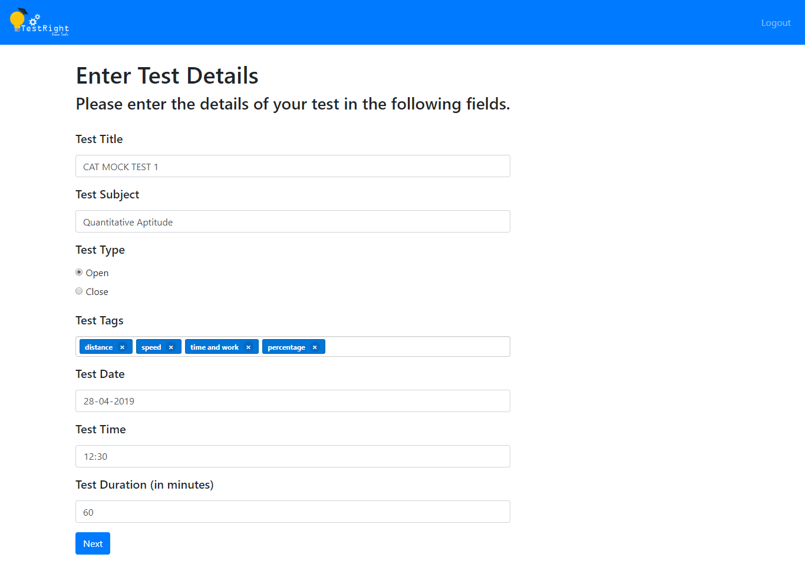View Results

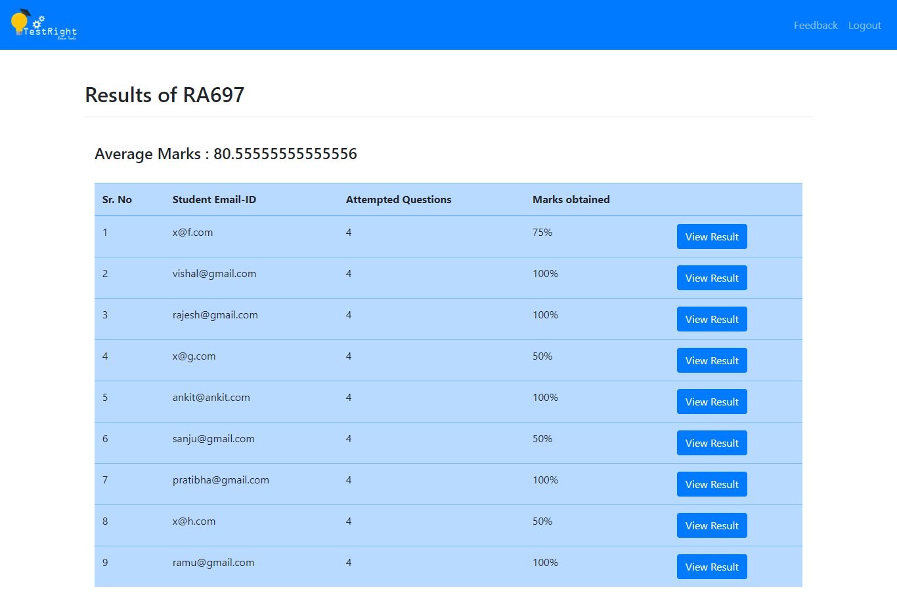

8. Testing

Testing is on of the major part of out project, as it is a complete client oriented project.

We completed our testing as follows:

1.Homepage responsiveness

2.Register and login credentials

3.Editing profile

4.Creating and editing test

5.Security Feature

We have successfully completed all our testing with successful implementation of all the features.

9. Conclusion

To conclude we would like to say that we have made this software with the main motive of targeting both the small scale firms(tuitions, private classes) as well as large organization, as not all can afford to buy the products available in the market.

Our product helps the client to conduct tests in both tech as well as non-tech backgrounds.

The main aim of keeping our product open-source is that we would appreciate contributors contributing new ideas to this project hence this would help many people around the world.